Bonus Lecture - Security - Login/Logout with Spring Boot and Thymeleaf

**Spring Security - Login/Logout with Spring Boot and Thymeleaf**

FAQ: Can you provide a code example of performing Spring Security login/logout with Spring Boot and Thymeleaf?

Answer:

Yes, here are code examples of Spring Security login/logout. I've extended the Employee Directory example with Spring Security.

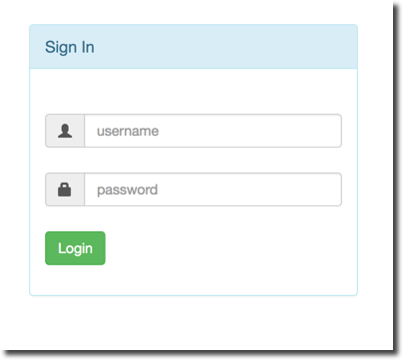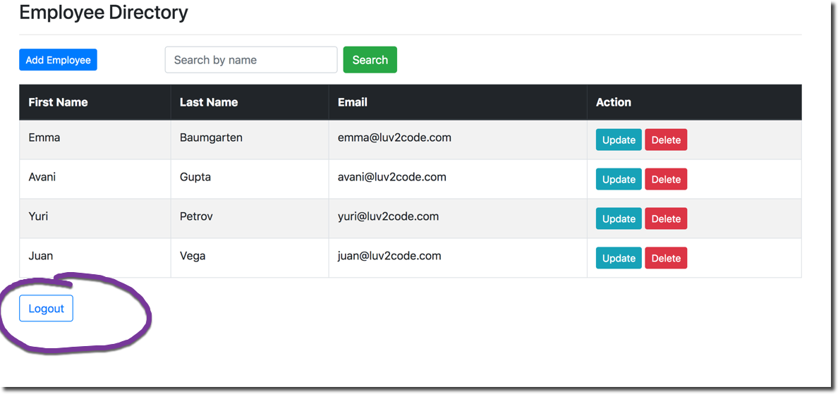

**Source Code**

Two versions of the source are available.

Version 1:  In-Memory Authentication

[bonus-thymeleafdemo-employees-security-with-in-memory-authentication.zip](https://drive.google.com/open?id=1ga5TC3DhGJA98dGRpuGrxuo6jTu_542A)

Version 2: JDBC Authentication with Encrypted Passwords

[bonus-thymeleafdemo-employees-security-with-jdbc-authentication.zip](https://drive.google.com/open?id=1d84g3Dj3Vks7aTe23M--l2k7LT6cgJO0)

Each project has a README.txt file. View this file for a high-level discussion of the source code.

Enjoy :-)